Memorandum

December 31, 2013

To: XXX, senior manager of planning

From: Cedric Justice

Subject: Existing Building Retrofits (EBR) and code overlap projections

I was asked to determine the **impact of codes on estimates of Existing Building Retrofits (EBR) savings** and determine the above-code value of the initiative. This memo provides background, discusses how I approached this topic, what assumptions I made, and provides the preliminary results of the analysis.

# Results of the Analysis

The **Q3 2013 EBR** model claims **30.7 aMW** over twenty years. For the sake of this analysis, our starting point is **49.4 aMW**, which reflects a larger market size and a savings rate that more accurately portrays the initiative logic.

With the assumptions I selected as well as the code-interactivity scenario I chose, my recommendation is to **reduce savings 3.0 aMW due to code interactivity.** This results in **46.4 aMW** over twenty years, but could be as low as 26.5 aMW if we take a strict code compliance tactic.

## Assumption selection

The most important parts of the analysis include the following assumptions:

* Selection of market size
* Selection of savings rate
* The code applicability for the measures used
* The likelihood of a building owner doing this work without the influence of EBR
* Whether building owners consider building energy systems in a typical, high-dollar retrofit

**I have included an appendix** (see Appendix A) that outlines the key assumptions used in the model. In it, I discuss each component I chose and why I used it in the model. The following table is a summary of those choices, which led to the 49.4 aMW figure.

Table 1 Chosen values: see Appendix for more detail

|  |  |
| --- | --- |
| Assumption | Chosen Value |
| Market Size | 204.2M ft2 |
| Savings Rate | U-shaped[1] |
| EUI | 16.7, decreasing 3.5% per year |

## Code Interactivity

Using the information in Table 1, there are several scenarios with respect to code interactivity that impact this initiative. The following table shows the range of values depending on how one interprets and estimates code interactivity and includes my recommended scenario.

Table 2 Code interactivity scenarios

|  |  |  |  |
| --- | --- | --- | --- |
| Scenario | Code Interactivity | Resulting aMW | Difference from original |
| Team’s recommendations | 7.2% | 48.5 aMW | -0.9 aMW |
| Planner’s recommendations | 19.2% | 46.4 aMW | -3.0 aMW |
| Strict code scenario | 100% | 26.5 aMW | -19.0 aMW |

Estimating the amount of overlap between code and EBR is an art rather than a science. Tripping code is a nuanced issue as I learned from the in-house expert on codes and standards. A strict code interpretation is not only inaccurate, but is not likely in the case of this initiative. There are components of HVAC, envelope, plug load, and lighting that will not be susceptible to code in practice, such as ducting for HVAC.

To tackle this issue, I used a table in the cost-effectiveness model to determine what percentage of the various components in a project overlap with code. Without having finished the market test, **this is a gross estimate** at best. See Appendix C for more detail.

# Where is more information available?

The first place for more information will be to reference the appendices in this document.

If you have further questions, please contact Emily Moore or organize a meeting with any of the relevant team members:

* XXX, Initiative Manager
* XXX, Product Manager
* XXX, Demonstration projects coordinator
* XXX, Codes and Standards Senior Manager

The working ACE model version used for this analysis, with its respective scenarios, is available on SharePoint in the EBR Initiative site.

# Appendix A

Table 3 Assumptions used in the model

|  |  |  |  |  |
| --- | --- | --- | --- | --- |
| Assumption | Starting Value | High value | Low Value | Chosen Value |
| Market Size | 104.4 M ft2 | 230.8 M ft2 | 104.4M ft2 | 204.2M ft2 |
| Savings Rate | 35% flat | 60% | 35% flat | U-shaped[2] |
| EUI | 16.7, decreasing 3.5% per year | 17.1, no decrease | 16.7, decreasing 3.5% per year | 16.7, decreasing 3.5% per year |
| Code interactivity | 0% | 7.2% | 100% | 19.2% |
| Resulting 20-year aMW | 19.9 | 69.5 | 7.8 | 45.3 |

This matrix shows the sensitivity of various variables. The analysis done in the memo uses the chosen values to exemplify the impact of code interactivity and what it means for the initiative. As we can see from the above table, the market size is a major driver in the 20-year savings. Many of the other factors have less sensitivity.

## Market size

The scenario analysis I am working from is assuming these variables in isolation.

The market size **ranges from 230.8M ft2 to 104.4M ft2** depending on the selection of the target market strategies. **At 230.8M ft2**, the current working model [3]would result in **42.0 aMW**. The **team chose 104.4M ft2** to base our current projections upon, which results in **19.9 aMW** over 20 years.

I find that number is too small because if this product is released into the market, I don’t believe that NEEA will be enforcing building type and square footage. Instead, I believe that the market will decide if this product is right for the building at hand. In order to stay conservative, I’m keeping the market size bounded by the office sector, but I believe that other commercial buildings will take this product on where appropriate.

Given that logic, I chose a value somewhere in between all the office buildings and the target market. This gives some leeway to buildings in Oregon and Washington that may have endemic problems but are smaller than 50,000 ft2. This conforms with the logic of one of our four pilot buildings, which is under 50,000 ft2.[4]

This results in a **market size** starting point of **204.2 M ft2.** In isolation (with all the other starting point variables held constant), this results in a 20-year value of **37.3 aMW,** a +17.3-aMW change from the starting point.

This table summarizes these figures:

Table 4 Market size sensitivity

|  |  |  |  |  |
| --- | --- | --- | --- | --- |
| Assumption | Starting Value | High Value | Low Value | Chosen Value |
| Market Size | 104.4 M ft2 | 230.8 M ft2 | 104.4M ft2 | 204.2M ft2 |
| Resulting 20-year aMW | 20.0 aMW | 42.2 aMW | 20.0 aMW | 37.3 aMW |

## Savings Rate

The assumed savings rate of **35% savings (5.85 kWh/ft2)** is the minimum figure a building that met the programmatic intent could achieve. That results in a savings of 45.7 aMW Demonstration project modeling supports a much higher savings rate. These early adopters save between **50–60%**, which supports the theory that with existing technology, this is possible. At a 60% savings rate, savings are **47.3 aMW,** a +27.3-aMW change from the starting point.

I am using a middle range, whereby the team estimated a variable savings rate. It is graphically interpreted here, and I am dubbing this the “**U-shaped values**”:

Table 5 The "U-shaped values" illustrated

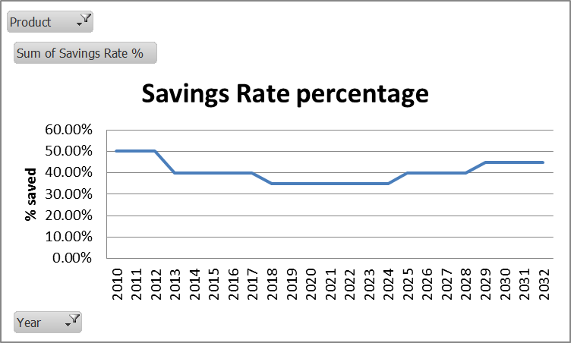

An important corollary is to see the market penetration theory on the same axis:

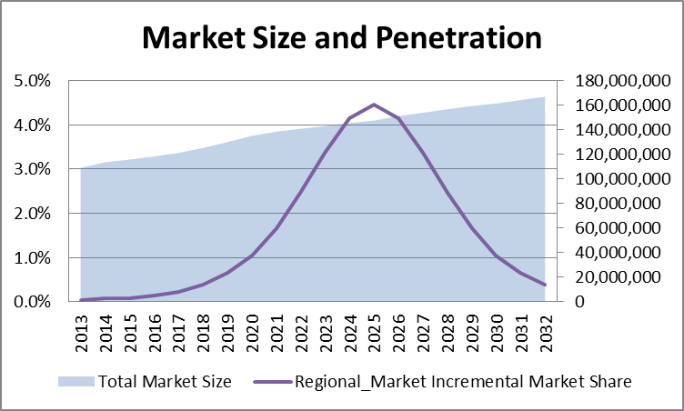

Using this graduated savings rate results in a 20-year figure of **25.7 aMW,** a +5.8 aMW change from the starting point.

|  |  |  |  |  |
| --- | --- | --- | --- | --- |
| Assumption | Starting Value | High Value | Low Value | Chosen Value |
| Market Size | 104.4 M ft2 | Using starting value to isolate variable | | |
| Savings Rate | 35% | 60% | 35% | U-shaped values |
| Resulting 20-year aMW | 19.9 aMW | 33.6 aMW | 19.9 aMW | 25.7 aMW |

## Code applicability

The crux of this case has to do with the code applicability and the intersection therein. In order to get a handle on this, I used the new-construction codes model and the changes slated for each code cycle by state. Before we can arrive at a variable or a result, we have to consider the following attributes:

* Likelihood in the market of EBR-style deep-energy retrofits
* Building energy systems’ likelihood to be changed out without the influence of EBR

### Likelihood of EBR-style Renovations

It is crucial to note that XXX Consulting’s baseline research will ultimately be the arbiter of this particular argument. However, in the interim, I was asked to quantify the code risk to the initiative.

I worked with the EBR team and the senior codes manager over the course of September and October of 2013 to create some assumptions. The team and I are all aware that these assumptions are based on gut instinct and are not backed with any data[5]. Nevertheless, for transparency and clarity, here are the assumptions the team devised:

Table 6 Population characteristics assumptions with respect to participant motivations

|  |  |  |  |  |
| --- | --- | --- | --- | --- |
| Category | % of savings booked to EBR | % that overlaps with code | % of population in category | Source |
| Participants who would never have done EBR | 100% | 0% | 50% | (20) Smith, E.; Jones, F.; Johnson, D. (2013). 'In-person meeting on above-code savings' |
| Planning a non-energy upgrade | 100% | 0% | 20% | (20)Smith, E.; Jones, F.; Johnson, D. (2013). 'In-person meeting on above-code savings' |
| Planned replacements | 76% | 24% | 30% | (20)Smith, E.; Jones, F.; Johnson, D. (2013). 'In-person meeting on above-code savings' |

The planned replacements portion of this is a derivation of the table created by the awareness of building energy systems discussion below.

In summary, with my planning judgment, this figure changes to the following table:

|  |  |  |  |  |
| --- | --- | --- | --- | --- |
| Category | % of savings booked to EBR | % that overlaps with code | % of population in category | Source |
| Participants who would never have done EBR | 100% | 0% | 50% | (20)Smith, E.; Jones, F.; Johnson, D. (2013). 'In-person meeting on above-code savings' |
| Planning a non-energy upgrade | 100% | 0% | 20% | (20)Smith, E.; Jones, F.; Johnson, D. (2013). 'In-person meeting on above-code savings' |
| Planned replacements | 49% | 51% | 30% | (21)NEEA (2013). 'Planning judgment' |

### Awareness of building energy systems

In the ACE model, I break out the four basic building energy systems into separate categories of HVAC, envelope, lighting, and plug load. In all four states, major renovations to these systems trip code. In practice, building owners will purposefully avoid “major” renovations to avoid tripping code. Additionally, code is only as effective in changing behaviors as it is enforced. The EBR team (and codes manager) all found that this has a meaningful impact on the code interactivities for this initiative.

#### HVAC Systems

Most of the team fully recognized that HVAC systems are usually the triggering event in engaging building owners and operators into the EBR program. From a baseline perspective, they estimated that 60% of the HVAC work would have happened without EBR involvement and would have been susceptible to code. The logic here is that ducting and many of the other components of HVAC work (especially from a dollar-value standpoint, which is where some of these estimates come from) are not impacted by code.

##### Planner’s response

To set context, the director of planning and evaluation and I had met with respect to this issue and she gave me clear guidance that the defensibility of these numbers needs to be at the level a planner at NEEA could stand up in front of the cost-effectiveness advisory committee and present these figures.

Given that context and to err on the side of conservatism, I chose a figure of **80% code interactivity**. It seems to me that this is the proverbial carrot that piques the interest of owners and that codes and standards have a major impact on the HVAC equipment being retrofitted in any building. The 20% remainder alludes to the prominent/normal behavior of building owners and operators simply avoiding retrofit and preferring the so-called “duct-tape method,” whereby they continue to make minor repairs to the equipment instead of retrofitting it completely.

Additional logic here involves the notion that the better the building’s mechanical systems, the more valuable the building becomes. That is a core strategy of EBR, and that is something I find reasonable and acceptable.

#### Envelope

The team was clearly in alignment that envelope issues tend to be the last issues addressed. Envelope issues, such as gaps and glazing (window) issues are a low priority in the scope of building operators’ work and tend to be very expensive to mitigate. For this reason, the team estimated that there was no overlap with code because EBR would be the sole reason for the building retrofit teams to do this sort of work.

##### Planner’s response

The logic of envelope issues holds for me, but I do think that in extreme cases, some building owners and operators would go to the extreme of replacing some envelope components. Additionally, I find that windows are susceptible to standards in the marketplace. The 100%-to-EBR logic only makes sense if windows are never replaced in commercial buildings, a practice I don’t believe to be reasonable. Additionally, I believe that some building owners see glazing as an opportunity to “spice up” their building: new windows are external and highly visible. If someone has a 20–50 year old building, they know that double-glazed windows are going to make their building look better and be greener.

I chose a value of **25% code-interactivity** due to this analysis. It seems reasonable to me that 75% of retrofit projects will not include envelope retrofits and that some of those projects would be avoided due to a building owner’s unwillingness to trip code—and therefore additional expense.

#### Lighting systems

Lighting is a fairly controversial issue for a few reasons. Many of the codes read with the ‘major renovation’ clause which tends to mean more than 50% of the space being altered would trip code. However, how one measures the space being altered is ambiguous and regularly avoided by building owners. On top of that, the EBR team has recognized that lighting tends to be the last component in the EBR retrofits that happens or more closely maps to tenant movements. Because of this, they gave EBR full “credit” for inciting the retrofits and deem the retrofits unlikely to trip code.

##### Planner’s response

I feel that lighting is becoming a more visible and “sexy” retrofit. With the advent of LEDs in the marketplace and the EISA legislation, lighting is getting a lot more attention in the residential and commercial space. Additionally, advanced lighting controls are entering the marketplace in a highly visible way, so there is more exposure to lighting and more likelihood that non-EBR practices will involve lighting projects.

I do agree that a certain deduction needs to be taken out with respect to the common practice. For these reasons, I chose a value of **50% code-interactivity**. The 50% not impacted by code falls under the logic of the avoidance of code and/or unawareness/unwillingness to change systems out, especially without a tenant relocation being in effect.

#### Plug Load

Plug load is not considered in building codes. Therefore, the team gave EBR full credit for the plug load savings practices.

##### Planner’s response

I agree with the team and agree that plug load has no intersection with code. There is a **0% overlap with code**.

#### Results of analysis

The results of the analysis end up altering the “planned replacements” portion of the participants in the 30% of participants that would have done work. The cross-product of this has a low impact on code sensitivity for the model.

The team’s values result in a figure of 76% of those projects being attributed to EBR, which results in an overall 20-year above-code figure of 19.4 aMW, a change of -0.5 aMW from the original 19.9 aMW given the isolation of this variable.

Using my figures, this goes to 18.3 aMW, which is a difference due to codes of -1.6 aMW.

# Appendix B

## Other Assumptions not changed

Other assumptions and factors can complicate the modeling. For archival purposes, I’m including some of the more important ones here.

### Model shape

Model shape defines market adoption and the maximum market penetration.

* Estimated market penetration modeled on an S-curve
* Estimated baseline penetration modeled on an S-curve

|  |  |  |  |
| --- | --- | --- | --- |
|  | Parameter | **Market Share** | **Naturally-occurring Baseline market Share** |
| **Base Year** | | 2013 | 2013 |
| **Initial Market Share (%)** | | ***0%*** | ***0%*** |
| **Max Potential (%)** | | ***33%*** | ***17%*** |
| **Remaining Saturation** | | **33%** | **17%** |
| **Hypergrowth (year)** | | ***2020*** | ***2025*** |
| **Number of years after growth for transformation completion (#)** | | ***9*** | ***15*** |
| **Market penetration at hypergrowth (%)** | | ***8%*** | ***8%*** |

### Measure life

Measure life has been held constant at 20 years.

### Incremental cost per unit

Currently is $4.00 per square foot. O&M costs are assumed to be ($0.10) per square foot, resulting in $3.90 per square foot in total.

### EUI

Energy Unit Intensity is [the 2009 CBSA](http://neea.org/docs/reports/2009NorthwestCommercialBuildingStockAssessment021CA220F212.pdf?sfvrsn=6) commercial building average (Appendix D) which is 16.7 kWh/ft2, 0.4 points less than the average office building. I chose this because of the potential for EBR to spread into other building types as well as the fact that 16.7 is more conservative than 17.1.

# Appendix C

## Code interactivity scenarios

For transparency’s sake, I’m including the various code interactivity scenarios.

|  |  |  |  |  |
| --- | --- | --- | --- | --- |
| Scenario Descriptor | Category | % of savings booked to EBR | % that overlaps with code | % of population in category |
| Team's values | HVAC | 40% | *60%* | 40% |
| Team's values | Envelope | 100% | *0%* | 25% |
| Team's values | Lighting | 100% | *0%* | 25% |
| Team's values | Plug load | 100% | *0%* | 10% |
| Planner's choice | HVAC | 20% | *80%* | 40% |
| Planner's choice | Envelope | 75% | *25%* | 25% |
| Planner's choice | Lighting | 50% | *50%* | 25% |
| Planner's choice | Plug load | 100% | *0%* | 10% |
| No code consideration | HVAC | 100% | *0%* | 40% |
| No code consideration | Envelope | 100% | *0%* | 25% |
| No code consideration | Lighting | 100% | *0%* | 25% |
| No code consideration | Plug load | 100% | *0%* | 10% |
| Strict code | HVAC | 0% | *100%* | 40% |
| Strict code | Envelope | 0% | *100%* | 25% |
| Strict code | Lighting | 0% | *100%* | 25% |
| Strict code | Plug load | 0% | *100%* | 10% |

The “Teams Values” and “Planner’s Choice” scenarios result in a cross-product that is used to determine the code interactivity.

1. See Savings Rate, below
2. See Savings Rate, below
3. The current working model is one that has integrated codes into it. The structure of the model is fundamentally different than the model that was submitted for Q3 2013 due to the injection of codes and the impacts of the savings rates.
4. While MT and ID tend to have these smaller buildings in general and the strategy needs to be adjusted to include that, I think that there will be some buildings in OR and WA that will also need a deep energy retrofit and will get them, despite not being in the target market sector.
5. In all of my models, unverified inputs are outlined in double-red lines.